**BÁO CÁO THỰC HÀNH LAB 1**

**LẬP TRÌNH HƯỚNG ĐỐI TƯỢNG**

**2.2.1**

**2.2.2**

**2.2.3**

**2.2.4**

**2.2.5**

**2.2.6**

**6.1 Write, compile and run the ChoosingOption program.**

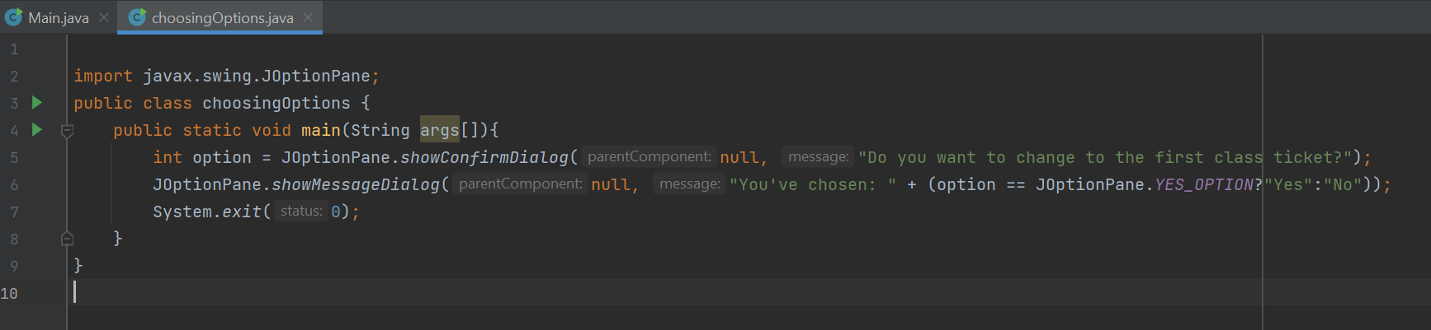

* **When Choosing Cancel: we got window**

* **Customize:**

**6.2 Write a program for input/output from keyboard.**

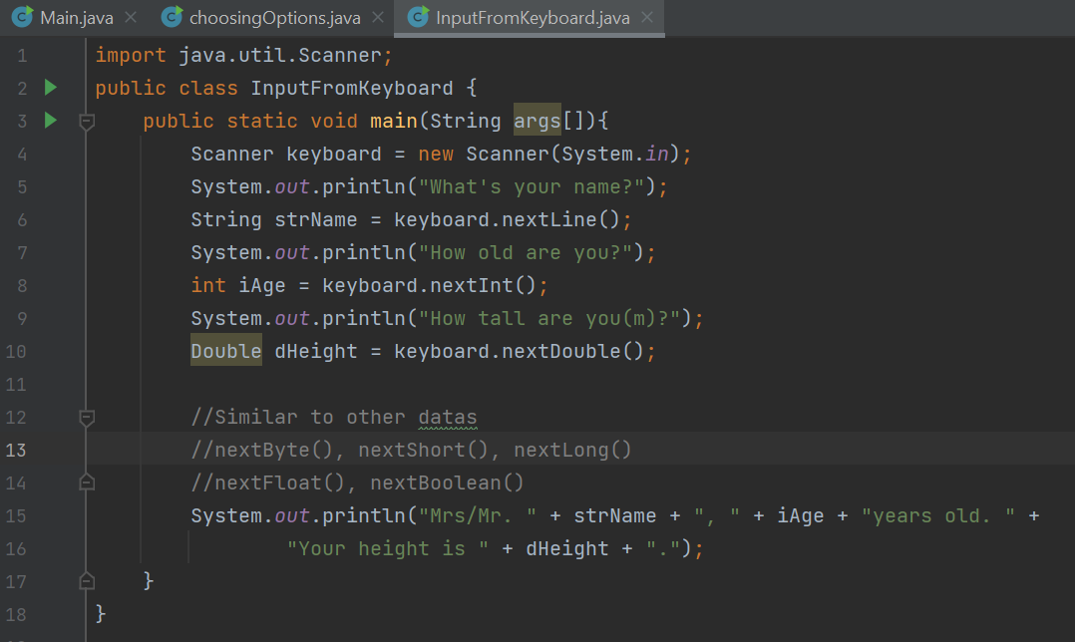

**6.3 Write a program to display a triangle with a height of n stars (*), n is entered by users.**

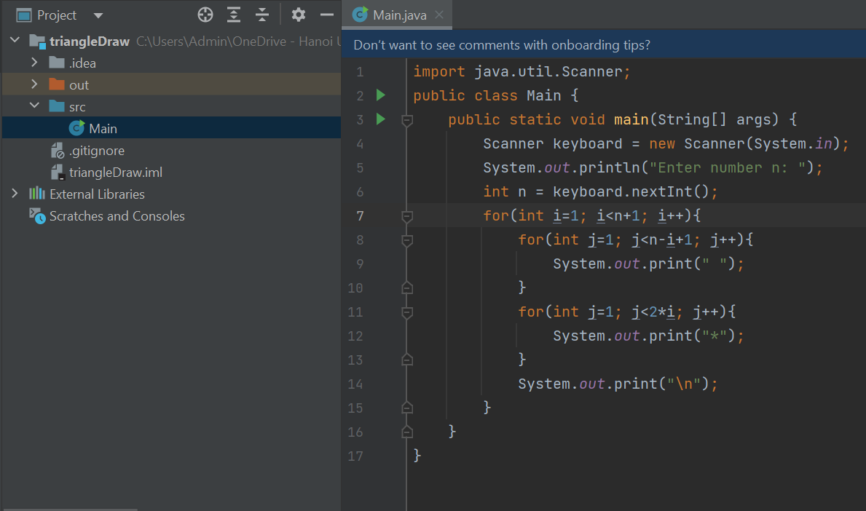

**6.4 Write a program to display the number of days of a month.**

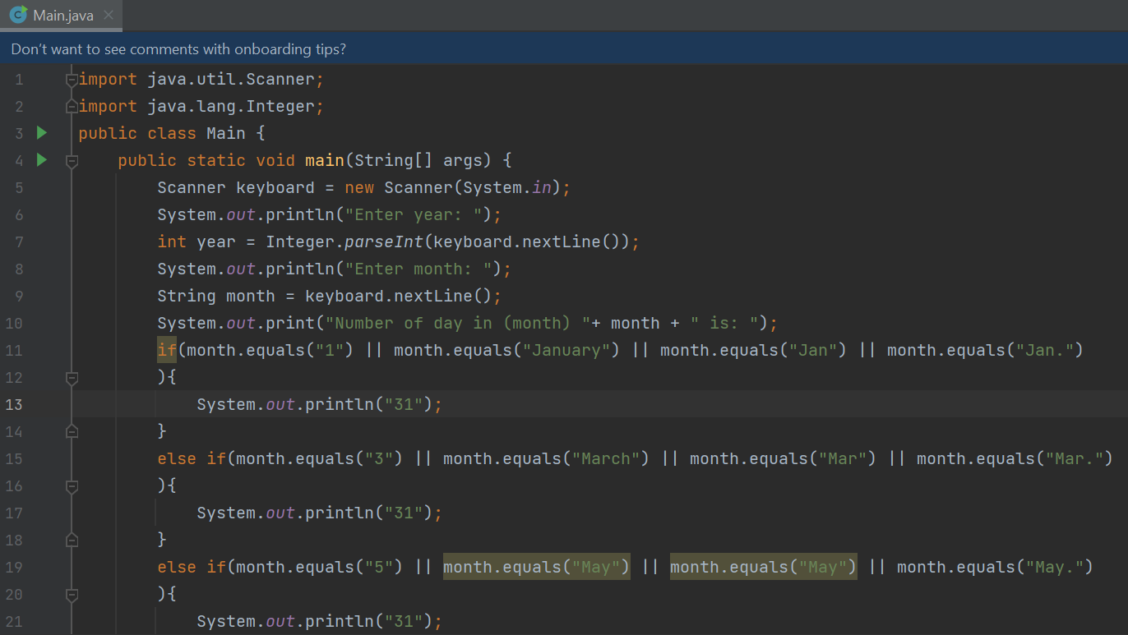

**6.5 Write a Java program to sort a numeric array, and calculate the sum and average value of array elements.**

**6.6 Write a Java program to add two matrices of the same size.**

